**Project Design Phase-II**

**Technology Stack (Architecture & Stack)**

|  |  |
| --- | --- |
| DATE | 20.05.2023 |
| TEAM ID | NM2023TMID12362 |
| PROJECT NAME | Industrial Workers Health and Safety System Based On Internet Of Things |

**Technical Architecture:**

The Deliverable shall include the architectural diagram as below and the information as per the table1 & table 2

Example: Thermal sensor with detection device

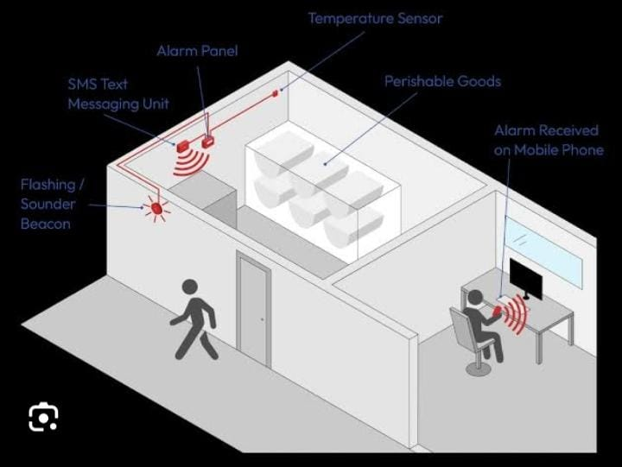

**Table-1: Application Characteristics:**

|  |  |  |  |
| --- | --- | --- | --- |
| **S.No** | **Characteristics** | **Description** | **Technology** |
| 1  2 | User interface  Application Logic | How user interacts with application e.g. Web UI, Mobile App, pc etc.  Logic for a process in the application | Computer in a user interact with an applications.  Electric, pneumatic, electro , pneumatic and acting controls. |
| 3 | Database | The sensor data and test data are collected using the OPC client. | An RTD (Resistance Temperature Detector) |
| 4 | Cloud database | Database service on cloud | triggering alarms, performing reports and archiving the harvested data in a compliant manner |
| 5 | File storage | File storage requirement | A temperature monitoring device (TMD) that records all temperatures at preset intervals |
| 6 | External API | Purpose of External  API used in the  application | IBM Weather API, etc. |

**Table-2: Application Characteristics:**

|  |  |  |  |
| --- | --- | --- | --- |
| **S.no** | **Characteristics** | **Description** | **Technology** |
| 1 | Open-Source  Frameworks | On-chip thermal monitoring for detecting local hot spots in high-performance processors. Various approaches have been reported. | An RTD (Resistance Temperature Detector) |
| 2 | Security  Implementations | controls and regulates the temperature of a particular environment | monitoring and controlling temperature in industrial plants, and medical facilities |
| 3 | Scalable Architecture | Supports higher workloads without any fundamental changes to it. | Thermocouples are inexpensive, durable, and can measure a wide range of temperatures. |
| 4 | performance | Self-powered, requiring no excitation, and can operate over a wide temperature range (up to 2000°C). | A thermocouple is a transducer that converts thermal energy into electrical energy |